Binary tree examples

# Adding

Add the following to a binary search tree.



"Banana", "Durian", cherry, ugli, tomato, gooseberry avocado, grape. (alphabetically, left to right)



# Traversals

3 traversals:

In order traversal (L,Root,R):

Preorder traversal (Root, L, R):

Postorder traversal (L, R, Root):

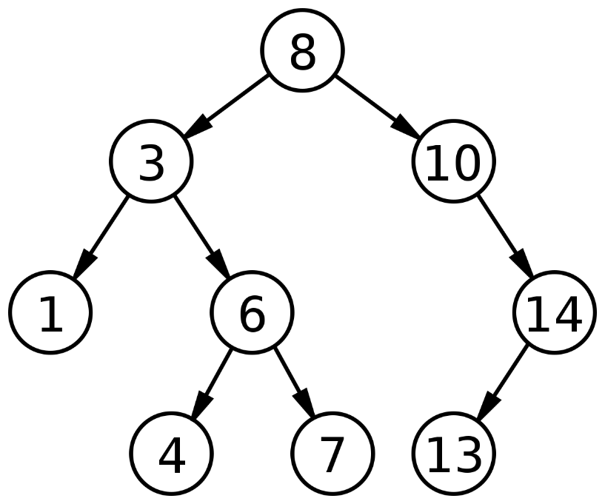

Make a BST of these and then do all traversals on them:



Python, JavaScript, Java, HTML, CSS, SQL, Haskell, C, Prolog, TypeScript, Kotlin, Lua.

Do the same for these: PC, MAR, MDR, IR, ACC, CU, ALU.